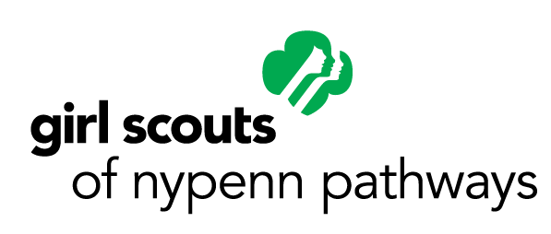

**Media Contact:**

Jaime Alvarez, Director of Communications & PR  
315.698.9400 x2049

[jalvarez@gsnypenn.org](mailto:jalvarez@gsnypenn.org)

# FOR IMMEDIATE RELEASE

**Sackets Harbor Girl Scout Troop Hosts Free Kindness Walk & Carnival June 22 as Part of Silver Award Project**

**Watertown, N.Y.** (June 4, 2019) —Girl Scout Troop 50051 of Sackets Harbor (part of the [Girl Scouts of NYPENN Pathways](http://www.gsnypenn.org/) Council) is hosting #cultivatekindness one step at a time, a free community walk and carnival later this month as part of their Girl Scout Silver Award Project. The Silver Award is the highest award a Girl Scout Cadette (grades 6-8) can earn. Girls who pursue their Silver Award look around their neighborhoods and/or schools and develop a project to make their community better in the process.

The troop’s Take Action Project for their Girl Scout Silver Award is focused on kindness. The public is invited to join them on a one-mile walk to celebrate kindness through the Village of Sackets Harbor on Saturday, June 22 beginning at 9:30 a.m. The girls have created signage with positive messages along the path. A free community carnival with games, attractions and food will follow at Sackets Harbor Central School, 215 S. Broad St. The carnival runs until noon.

The troop has been busy painting rocks with positive words and messages for a Kindness Rock Garden that will be established at the school and village office as part of their project. Rocks will be available for painting during the carnival. Follow the troop’s progress in preparation for their event and for additional news about their Silver Award Project on Facebook at [#cultivatekindness](https://www.facebook.com/groups/353102382171391/).

This event is open to media coverage. Questions? Contact Girl Scout Troop 50051 co-Leader Brenda Jock Derouin at 315.778.9437 or [docjock9@yahoo.com](mailto:docjock9@yahoo.com).

Girl Scouts serves girls in grade K-12. Annual membership is $25. Financial assistance is available. To register a girl online, visit [gsnypenn.org/join](https://www.gsnypenn.org/join). To become an adult volunteer, learn more at [gsnypenn.org/volunteer](https://www.gsnypenn.org/volunteer).

###

**Girl Scouts of NYPENN Pathways, Inc.**Girl Scouts is the preeminent leadership development organization for girls. We believe in the power of every G.I.R.L. (Go-getter, Innovator, Risk-taker, Leader)™ to change the world. Our extraordinary journey began more than 100 years ago with the original G.I.R.L., Juliette Gordon “Daisy” Low. Today we continue the Girl Scout mission of building girls of courage, confidence, and character, who make the world a better place. GSNYPENN is chartered by Girl Scouts of the USA to administer the Girl Scout program in 24 counties of New York and two in Pennsylvania. We offer every girl a chance to practice a lifetime of leadership, adventure, and success. Learn more by visiting [gsnypenn.org](http://www.gsnypenn.org/), calling 1.855.213.8555, emailing [info@gsnypenn.org](mailto:info@gsnypenn.org) or following @GSNYPENN on [Facebook](https://www.facebook.com/GSNYPENN/), [Twitter](https://twitter.com/GSNYPENN), [Instagram](https://www.instagram.com/gsnypenn/) and [YouTube](https://www.youtube.com/user/GSNYPENN).