GSNYPENN Silver Award
Requirements, Rubric and FAQ for Troop Leaders

This is a guide to help you determine if the Silver Award project idea meets the standards to earn the highest award a Cadette can earn. Items referenced in this document can be found here: https://www.gsnypenn.org/en/about-girl-scouts/our-program/highest-awards/silver-award.html
Individual final reports are due September 1 immediately after the girl’s 8th grade graduation. This is true for all girls if the team is made up of girls in different grades and only 1 is in 8th grade.
Before getting started, all team members must complete the Silver Award prerequisites
Prerequisites
- The Silver Award team can be 1, 2, 3 or up to a maximum of 4 girls.
- Each member of the Silver Award team must be a registered GSNYPENN Pathways Cadette Girl Scout
- Each member of the Silver Award team is between grades 6-8
- Each member of the Silver Award team has completed at least 1 Cadette journey (including the take action project)
- Each member of the team has completed the Silver Award video training found on our website and submitted their own quiz
- Each member of the Silver Award team has read the Silver Award Guidelines

After the prerequisites are completed, girls need to think about what specifically they want to do. They will explore the community and research the issue they are interested in.
- What is the primary issue the project is concerned with?
Example: the free local community garden plots are not yielding as much produce as in the past.
- What is the root cause of that issue?
Research shows that one root cause could be the nutrients in the soil are depleted; another root cause could be destruction/eating from animals/insects.
- What is the specific project idea and how does it address the root cause (why is it needed?)
There will be a 2 pronged approach: install a fence to keep larger animals out and work with a Master Gardener to come to the garden to provide education directly to those using the plots on safe, environmentally friendly ways to protect plants.
- How will the project reduce or eliminate the root cause of the issue?
The animals will now have a barrier to prevent them from accessing the garden plots and gardeners will also have the knowledge to be able to safely deter rodents, insects, slugs and other diseases from destroying their plants.
Once girls have thought about their idea, they may need to make adjustments or conduct additional research to make sure that their ideas will meet the basic requirements of earning the Silver Award.
Use this rubric to determine if your idea meets the basic requirements of the Silver Award
Meets Criteria | Does Not Meet Criteria | Basic Requirements
 |  | The project is Take Action*, NOT Community Service. The project is carried out WITH the community, not FOR the community
 |  | The project addresses an issue by reducing or eliminating its root cause
 |  | The project is large enough that each girl will be able to complete a minimum of 50 hours of work on the project. Each girl must keep a detailed timeline of their hours. See FAQ in this document to make sure you understand how we allow the hours to be allocated.
 |  | Rules, regulations and safety issues are identified and plans are in place to address them (money earning policies must be followed)
 |  | Research was conducted to determine what is causing the issue and what, if any, solutions are in place to alleviate the root cause. Research includes talking to several community members/experts AND library/online research from credible sources.
 |  | The project is either: a new solution (current measures aren’t working or there is no solution in place), or similar to the solution(s) currently in place but adding to them because they are not sufficiently addressing the root cause. In either case, your research needs to support that project is a solution that will reduce or alleviate the root cause of the issue
 |  | The target audience is clearly identified and reaches beyond the team’s immediate community (their troop, classroom, street they live on, etc.) A Silver Award can benefit Girl Scouts**
 |  | The project actively engages /educates members of the community
 |  | The project will make a long term impact on the root cause (there is a sustainable plan)
 |  | Team is able to Measure impact (what can be counted or measured?)
*A Silver Award must be a Take Action project! For more information, make sure to read the Silver Award Guidelines and check out this Community Service vs Take Action activity
**Silver Awards may benefit the larger Girl Scouting community. However, girls need to pick their issue first, then decide who is the best target audience. For example, a Girl Scout is concerned about obesity in children and wants to create a fun exercise and nutrition program. There are many organizations she can work with and approaches her council to see if they would like to use a program like this as she knows how many kids she can reach at camp. A Silver Award must reach beyond a troop or individual service unit.
Red Flags to watch out for that might NOT qualify for a Silver Award:
- Volunteering for another organization or existing program is community service, not take action
- Collecting, or making, and donating items (toys, food, books, bottles & cans, etc.) is community service. Performing short-term tasks (organizing materials/painting a room/fixing broken furniture) for an organization is community service. These types of activities may be PART of a larger project.
- The project must directly affect the issue. Building a Little Library to address low literacy rates does not do that in and of itself – it only supplies books. The solution must address the root cause of low literacy rates if that is the goal of your project (what does the research tell you about effective ways to do that?)
- Multiple teams may NOT be collaborating on the same Silver Award project as other teams.
GSNYPENN Silver Award Resources and FAQs

Community Service Project vs. Take Action Project:
Community service projects are acts of kindness and important ways to help something or someone right now. They are commonly short-term projects that almost always multiply efforts that are already in place. Examples include collecting food for an existing food pantry, providing clothing or toiletries to people who have suffered during a disaster, cleaning up a rundown playground, or picking up trash at a park, forest, or beach.

Girl Scout Take Action projects address an issue by tackling the factors that cause or contribute to it. As you may expect, these projects have a far-reaching influence over a longer period of time. They’re designed to change something for the better by reducing or eliminating a root cause of an issue. Projects associated with Journeys and the highest awards (the Girl Scout Bronze, Silver, and Gold Award) are Take Action projects.

When you take action, you work as a team to: Here are ways to create sustainable change:
- Identify a problem 1. Make your solution permanent
- Research the root cause of the problem 2. Educate and inspire others to be part of the change
- Come up with a sustainable solution 3. Change a rule, regulation, or law
- Develop a team plan (who will it help and how) 4. Work with a community organization to take over
- Put the plan into action (how will you know you
met the goal)
6. Reflect on what worked, what didn’t, and what you’ve learned

Examples

Community Service Project | Take Action Project
Addresses an immediate need in the community | Addresses the root cause of an issue in the community
A project done FOR the community (i.e. you plan a donation drive for an issue you see) | A project done WITH the community (i.e. you work with an organization to solve an issue)
A one-time project that helps something or someone now | A long-term project that is sustainable and makes a lasting impact

Mind-Mapping Tool (Example):
Create your own mind-mapping diagram like the one shown here, using one of the issues facing your community. There is a template in the next page for you to use. Follow these instructions:
- Write the community issue in the middle of the paper or anywhere that works for you
- This about what some of the causes of this issue could be. Why is there litter all over the park? Why do animals get into the trash? What happens when they get in the trash? Why do people think litter is not their responsibility? Keep asking questions until you can’t go further (and you can use some research to look up why people litter or what cause so much litter to be in the environment to help with this exercise.)
- Now, try connecting the different causes you come up with to each other and to the main issue. How do the causes connect to each other? Do you see a pattern?
- Pick a root cause that you will address in your take action project. Working with the local park, we chose to add more trash and recycle bins as the research showed that was the most reported reason people littered.
This activity will help you come up with different ways to approach a problem, as well as different ways you might go about addressing it.
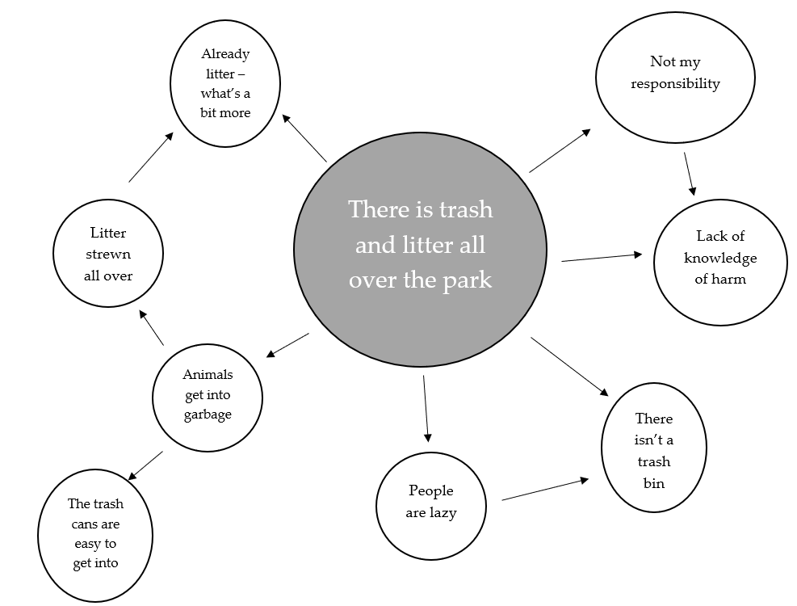

Mind-Mapping Tool:

FAQs:
Hours – Required 50 minimum per girl
  - What counts toward my 50 hours?
    - Research & Planning (before approval) = 10 hours max
    - Paperwork = 5 hours max
    - Money Earning = 5 hours
    - Implementation & Promotion = 35

  - What does not count toward the 50 hours:
- Completing Journey or required training
- Money earning activities over 5 hours
- Research & Planning prior to approval more than 10 hours
- Travel time (i.e. driving to get materials or to get to location) [UNLESS you are actively working during the trip]
- Implementation & Promotion prior to approval
- Time working on the project by other people

No splitting projects by grade
All project final reports must be submitted by September 1 when the oldest girl/s in the group earning the award are entering 8th grade. For example, if you started the project with 6th, 7th and 8th grade girls, all girls must complete the requirements when the older girl/s enter 9th grade in the fall and be included on the final report submission. If they are not able to have the project completed, the girls entering 7th or 8th grade can work on a different project to earn the award.
Money Earning Activities
If your project requires a money earning activity, a request must be completed and submitted to NYPENN. Please note that if your troop has not participated in both the Cookie Sales and the Fall Product Sales you will not be eligible to participate in a money earning activity to support your project.
https://www.gsnypenn.org/content/dam/girlscouts-gsnypenn/documents/volunteer_resources/GSNYPENN%20MY2019%20Policies.pdf
Starting at the bottom of page 18 – 20 is the money earning policies for our council.
Extensions
There are no extensions. Plan ahead and don’t wait until the last minute to begin the project. Provide extra time to account for unforeseen issues.
Final Report
Each girl must submit a final report with her own detailed timeline/log of hours of the work she did. You can find links to some log of hours template options on the Silver Award page.
If you have any concerns about your project, including hours or needing to go past the Sept. 1 deadline, please contact:
LeAnn Keim - Phone: 607.323.1925 - lkeim@gsnypenn.org

